**Project 2 Proposal**

David Chao

Chris Elliott

Sebastian Munoz

Using the CPS (Current Population Survey) dataset provided by Federal Reserve of Kansas City we will determine if there is any correlation between employment levels with education, age or the State one lives in. In particular we are interested in whether higher education means lower unemployment. Does age play a factor in unemployment? This dataset will encompass October 2018 through October 2019.

**Dataset:**

<https://cps.kansascityfed.org/cps>

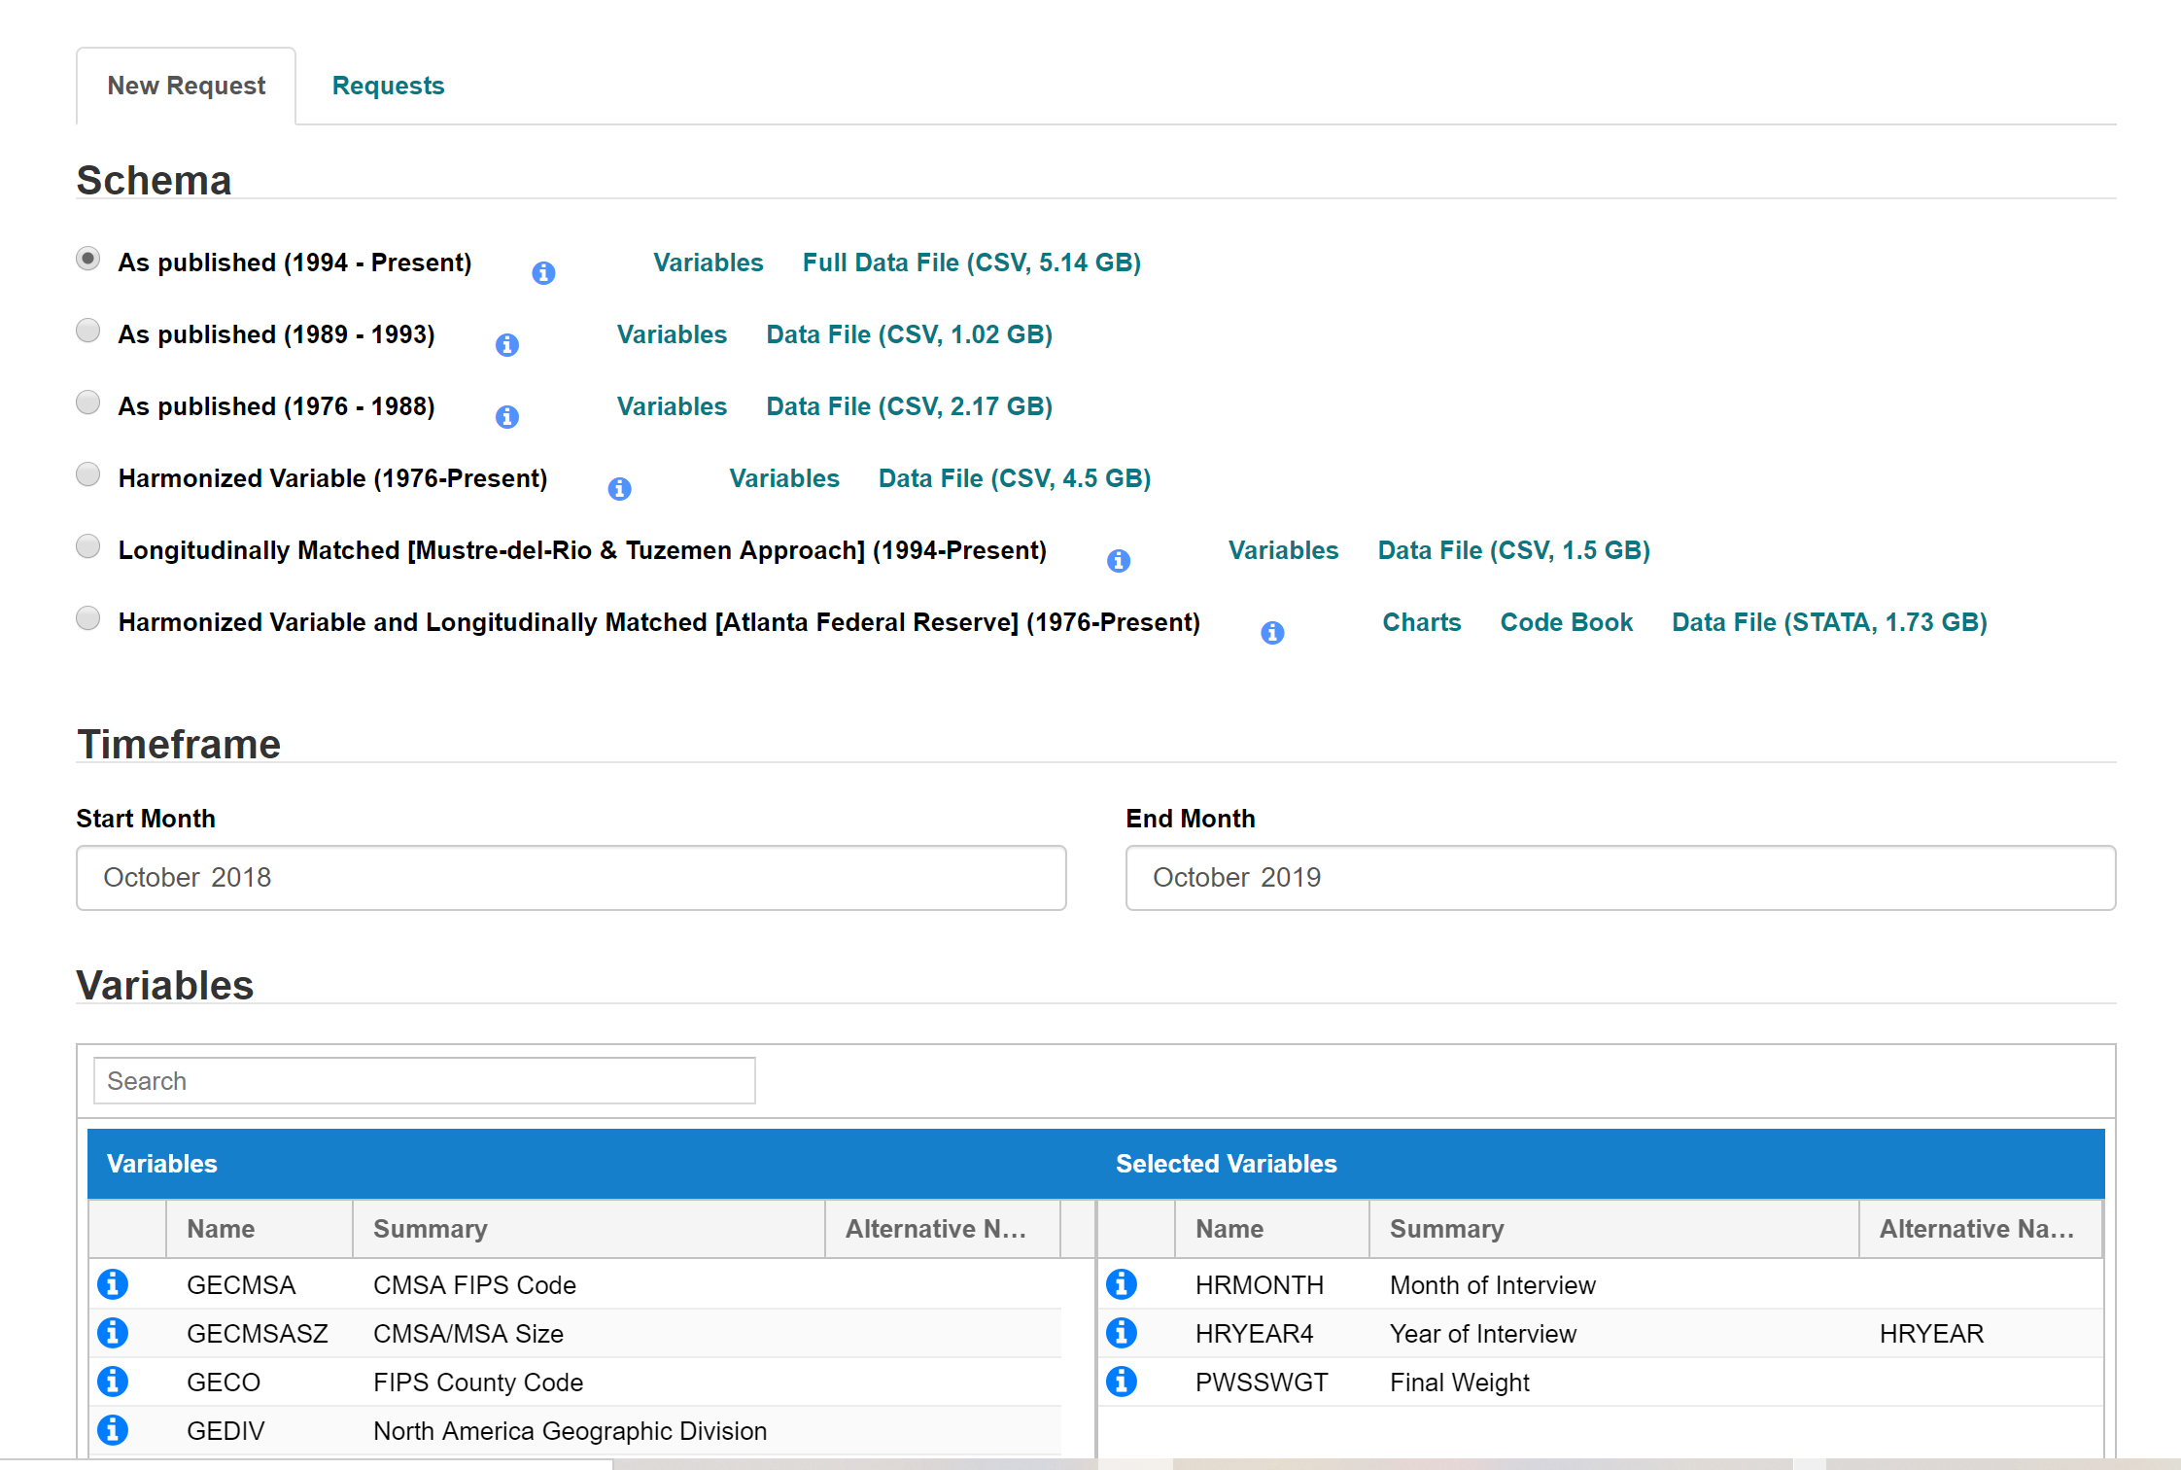

We will be building a basic HTML page that describes what we think we will get before doing the analysis vs what the data shows after the analysis. It will have charts comprised using DS3 and leaflet. It will be interactive for users to click on the chart.